Order/Material Reconciliation and Disposition
- Warehouse & Administration Departments | Reconcile past due order paperwork as well as the staged material racks for the following three scenarios:  - Orders on the “Orders awaiting Delivery, Pick Up & Invoicing” report with material still on the floor,  - Orders on the report and material cannot be found,  - Material on the floor and no order on the report.  Scenarios 2 and 3 must reviewed and reconciled monthly.  Staged material is material that may be found in the Will Call, Brokered, On Hold or Receiving racks. Identify and make known when you have either paperwork or material that cannot be reconciled or found on your open order report. Ask Supervisor for assistance in locating any material not found in these locations.  Additionally check Business System order number and note status of orders (i.e., billed, cancelled, etc.) in attempts to reconcile correctly.  Forward list of orders in question to Inside Sales Manager (ISM) or designee to delegate to Sales Rep for disposition.
- Sales Department | Contact customer and determine whether they already received their material or if they are still going to pick up material. If customer is going to pick up material, Sales Rep updates date with new agreed upon pickup date, or make other arrangements for delivery.  If customer cancels the order and material was not cut, write up Sales Order Cancellation Form (SOC001) and submit to ISM for approval. If material has been cut or was a buyout, bill the order and then determine if a credit note must be written per company policy.
- Warehouse Department | - Disposition material in the following manner:  - Material returned to stock must maintain traceability to Pack# and Heat#.  - If a credit note was written, disposition material as determined per credit note resolution. Document on Inventory Disposition Form (ID001), if required, or record action on the credit note signing off on disposition and forward to Purchasing.

“Handling” General Requirements
- Warehouse Department | - Segregation  - Product with different heat numbers of the same item stored in the same location will be separated by using physical heat separators, such as steel strips or straps where appropriate, or where appropriate, different heat numbers of the same item stored in the same location can be differentiated by using paint striping (partial color-coding ends) and marking the appropriate stock tag. Is it the correct grade and spec as evidenced (key word here) by marking and documentation both on packing slips and metallurgical (MTR) backup?  - Storage  - New Material will not be stocked without proper identification or MTR’s and until fully received in the Business System.  - All supplier packaging / identification must be removed from all material prior to stocking or releasing for shipment.  - Customer returned material will not be stocked and must remain in Hold Area until dispositioned unless RG001 tag directs return to stock and is stamped by Receiving Inspector.  - Sheet products must be stored on skids. No sheet rems less than 5 Ft. are permitted in the stocking locations.  - No more than one skid of copper, aluminum, brass or stainless per stocking location.  - Skids of Cold Roll, Hot Roll and P&O may be stacked with 4”x4” blocking between skids.  - Any Material found not in the proper stock location should be communicated via the Stock Problem Form (ST003). Material out of the proper stocking location must be moved to the proper stocking location or the stocking location must be changed to reflect the new location.  - Non-conforming material (damaged material, bent bars, etc.) found in stocking locations must be removed and processed per QSP 13.1 or recorded on the ID001 form to be moved to Retail via “7418” type order or scrapped.  - Material not identified with a stocking tag on either the material, skid or storage pan must be researched, inspected, and re-tagged per QSP 10.1, if possible. Otherwise, material must be recorded on the ID001 form to be moved to Retail via “7418” type order or scrapped.
- Warehouse Department | - Material Locations and Definitions  - Hold Area – Area in warehouse for material in transition from inspection to stocking, non-conforming material, returned material, refused material, material of unknown origin, or orders on hold/futures.  Receiving hold areas vary by branch location but must be clean, safe, designated and marked with ample room to accommodate warehouse equipment used for stocking, such as forklifts.  - Stock – Stock materials are located in primary stocking locations, backup locations or a designated hold area only.  - Buy Out/Brokered Material – Material purchased for a specific order not requiring a permanent stocking location.  - Aluminum Architectural items (6063)  - Only clean cotton gloves must be worn to handle this cosmetic product.
- Resources | Tools, Max Skid Size/Wt., how items are separated, tools, rules, rem size, skid max.

Reference and Applicable Documents
Product Storage and Preservation (QSP 15.1)
Sales Order Cancellation Form (SOC001)
Inventory Disposition Form (ID001)
Orders Awaiting Delivery, Pick Up and Invoicing Report

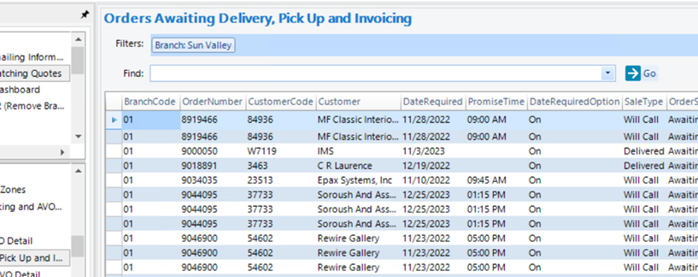

Revisions Table
Date | Description of Change | Approved by
TBD | Instruction added to specify reconciliation and disposition actions. | Penny Brown

